International Economics: Theory and Policy, 12e (Krugman)
Chapter 20 Financial Globalization: Opportunity and Crisis

20.1 The International Capital Market and the Gains from Trade

1) What would best describe the international capital markets?
A) the market of exchange of bonds
B) the market of exchange of stocks
C) the market of exchange of real estate
D) the market in which residents of different countries trade assets
E) the currency market
Answer: D
Difficulty: Easy
AACSB: Application of knowledge

2) The international capital market is
A) the international currency exchange.
B) a market in which capital assets are exchanged for services.
C) the market that is subject to intense regulation and must file a report to the Basel committee on a biannual basis.
D) not really a single market, but a group of closely interconnected markets in which asset exchanges with some international dimension take place.
E) an organization of fiscal policies that dictate international trade.
Answer: D
Difficulty: Easy
AACSB: Application of knowledge

3) Main actors in the international capital markets do NOT include
A) casinos and gamblers.
B) commercial banks.
C) corporations.
D) nonbank financial institutions.
E) central banks and other government agencies.
Answer: A
Difficulty: Easy
AACSB: Application of knowledge

4) International currency trades take place in the ________ market, which is an important part of the international market.
A) foreign exchange
B) money
C) stock
D) financial
Answer: A
Difficulty: Easy
AACSB: Application of knowledge

5) International capital market's activities take place in
A) a network of world financial centers linked by sophisticated communication systems.
B) the stock exchange worldwide.
C) only online platforms that allow lenders and borrowers to meet.
D) governments' regulated financial centers.
Answer: A
Difficulty: Easy
AACSB: Application of knowledge

6) The assets traded in the capital market do NOT include
A) durable goods and non-tradable services.
B) stocks.
C) bonds.
D) bank deposits denominated in different currencies.
Answer: A
Difficulty: Easy
AACSB: Application of knowledge

7) Describe three types of gains from trades?
A) trades of exchange rates for goods or services, trades of goods or services for property, and trades of gold for textiles
B) trades of goods or services for goods or services, trades of goods or services for assets, and trades of assets for assets
C) trades of imports for exports, trades of exports for imports, and trades of natural resources for financial assets
D) trades of services for goods, trades of currency for services, and trades of one type of currency for another
E) trades of current goods for future services, trades of currency for gold, and trades of one type of currency for another
Answer: B
Difficulty: Easy
AACSB: Application of knowledge

8) Which of the following statements is the MOST accurate?
A) By providing a worldwide payments system that lowers transaction costs, banks active in the international capital market enlarge the trade gains that result from such exchanges.
B) By providing a worldwide payments system that raises transaction costs, banks active in the international capital market enlarge the trade losses that result from such costs.
C) By providing a worldwide cryptocurrency payments system, banks active in the international capital market maximize customers' gains from trade exchanges.
D) By providing a worldwide risk-free payments system of digital currencies, banks active in the international capital market minimize customers' losses from trade exchanges.
Answer: A
Difficulty: Easy
AACSB: Application of knowledge

9) Intertemporal trade is
A) the exchange of goods but not services for claims to future goods.
B) the exchange of services but not goods for claims to future services.
C) the exchange of goods and services for claims to future goods and services.
D) the exchange of domestic goods and services for foreign goods and services.
E) the type of trade that the U.S. government focuses most upon.
Answer: C
Difficulty: Easy
AACSB: Application of knowledge

10) The importers' ability to obtain foreign goods today in return for a promise to repay soon after they have sold the goods to domestic customers is an example of
A) intertemporal trade.
B) trade of assets for assets.
C) risk-free trade.
D) pure asset swap.
Answer: A
Difficulty: Easy
AACSB: Application of knowledge

11) Trade in assets between countries, like trades involving goods and services,
A) can yield benefits to all the countries involved.
B) will always make all countries worse off.
C) usually benefits one country and harms the other.
D) never bring benefits to any country involved.
Answer: A
Difficulty: Easy
AACSB: Application of knowledge

12) When selecting assets, people make decisions based on the riskiness of each asset's return. People dislike risk and economists call this property of people's preferences
A) risk averse.
B) risk dislike.
C) risk neutral.
D) risk loving.
Answer: A
Difficulty: Easy
AACSB: Application of knowledge

13) What is the basic motive for asset trade?
A) the belief that large risks will lead to large returns
B) restoration of the balance of payments
C) portfolio unification
D) economic stability
E) increase expected returns and reduced risk
Answer: E
Difficulty: Easy
AACSB: Application of knowledge

14) Using international asset trade, countries can
A) never really eliminate all risk.
B) eliminate all risk.
C) actually increase their risk in some cases.
D) eliminate all their risk except for emerging markets.
E) never really diversify their holdings.
Answer: A
Difficulty: Easy
AACSB: Application of knowledge

15) If you are offered a gamble in which you win 500 dollars 3/8 of the time and you lose 500 dollars 5/8 of the time, what is your expected payoff and your behavior given that you are a risk-lover?
A) $500, take the gamble
B) -$125, take the gamble
C) -$125, it is unclear what you would do without further information
D) $500, decline the gamble
E) -$125, decline the gamble
Answer: C
Difficulty: Easy
AACSB: Application of knowledge

16) Suppose one is offered a gamble in which you win $1,000 half the time but lose $1,000 half the time. Since in this case one is as likely to win as to lose the $1,000, the average payoff on this gamble—its expected value—is:
0.5 ∗ $1,000 + 0.5 ∗ (-$1,000) = 0.

Under such circumstances
A) no one will take the gamble.
B) risk averse individuals will take the gamble.
C) risk lovers individuals will not take the gamble.
D) risk neutral individuals will not take the gamble.
E) risk lovers and risk neutral individuals may take the gamble.
Answer: E
Difficulty: Easy
AACSB: Application of knowledge

17) For most practical matters, economists assume that
A) individuals are risk neutral.
B) individuals are risk lovers.
C) individuals are risk averse.
D) most individuals are risk lovers.
E) most individuals are risk neutral.
Answer: C
Difficulty: Easy
AACSB: Application of knowledge

18) People who are risk averse
A) value a collection of assets only on the basis of its expected returns.
B) value a collection of assets only on the basis of the risk of that return.
C) value a collection of assets not only on the basis of its expected returns but also on the basis of the risk of that return.
D) are less likely to invest in life insurance.
E) are less likely to have a diverse portfolio.
Answer: C
Difficulty: Easy
AACSB: Application of knowledge

19) The idea of risk aversion
A) is at odds with the idea of insurance.
B) helps explain the profitability of insurance companies.
C) has nothing to do with insurance companies.
D) helps explain the losses suffered by the insurance industry.
E) helps explain why insurance companies in the long run are zero profit companies.
Answer: B
Difficulty: Moderate
AACSB: Application of knowledge

20) Risk averse people
A) will never hold bonds denominated in several different currencies because of transaction costs.
B) will always hold bonds denominated in several different currencies because of transaction costs.
C) may hold bonds denominated in several different currencies.
D) may hold bonds denominated in several different currencies only if satisfying the well known interest party condition.
E) will hold only domestic bonds because of the home bias effect.
Answer: C
Difficulty: Easy
AACSB: Application of knowledge

21) Which of the following statements is the MOST accurate?
A) International trade in assets can make both parties to the trade better off by allowing them to reduce the riskiness of return by portfolio diversification.
B) International trade in assets can make both parties to the trade worse off by allowing them to increase the riskiness of return by portfolio diversification.
C) International trade in assets can make both parties to the trade worse off by allowing them to eliminate all risk by portfolio unification.
D) International trade in assets can make both parties to the trade better off by allowing them to eliminate all risk by portfolio unification.
Answer: A
Difficulty: Easy
AACSB: Application of knowledge

22) International trade reduces the risk by allowing both parties to trade to divide their wealth among a wide spectrum of assets. This is described as
A) portfolio diversification.
B) portfolio unification.
C) risk aversion.
D) asset swap.
Answer: A
Difficulty: Easy
AACSB: Application of knowledge

23) Imagine that there are two countries, Home and Far Far Away, and that residents of each own only one asset, domestic land yielding an annual harvest of mangoes. Assume that the yield on the land is uncertain. Half the time, Home's land yields a harvest of 5,000 tons of mangoes at the same time as Far Far Away's land yields a harvest of 2,500 tons. The other half of the time the outcomes are reversed. The average for each country mango harvest is
A) 2500.
B) 2750.
C) 3500.
D) 3750.
E) 3000.
Answer: D
Difficulty: Easy
AACSB: Application of knowledge

24) The two types of trade, intertemporal and pure asset swap ________ perfect substitutes, because ________.
A) are; they both offer considerable payoff and are equal in the long run
B) are; they both involve the smoothing out of now and future consumption
C) are not; asset swapping is immediate and involves only assets, while intertemporal trade takes two time periods and involves both assets and goods/services
D) could possibly be; different economic states occur at different points in time
E) are not; asset swapping never relates to intertemporal trade
Answer: D
Difficulty: Easy
AACSB: Application of knowledge

25) Equity Instruments include
A) stocks.
B) bonds.
C) banks deposits.
D) receipts.
E) bank statements.
Answer: A
Difficulty: Easy
AACSB: Application of knowledge

26) Asset trades that deal with debt instruments are best described as
A) share of stock.
B) exchange rate.
C) receipts.
D) factors.
E) bonds or bank deposits.
Answer: E
Difficulty: Easy
AACSB: Application of knowledge

27) Asset trades that deal with equity instruments are best described as
A) share of stock.
B) exchange rate.
C) bonds.
D) bank deposits.
E) factors.
Answer: A
Difficulty: Easy
AACSB: Application of knowledge

28) Who are the main actors in the international capital market?
Answer:
(1) Commercial banks
(2) Corporations
(3) Non-bank financial institutions, such as insurance companies, pension funds, and mutual funds. This includes investment banks, which specialize in underwriting sales of stocks and bonds by corporations and in some cases governments.
(4) Central banks and other government agencies
Difficulty: Moderate
AACSB: Application of knowledge

29) Why is the foreign exchange market an important part of the international capital market?
Answer: The foreign exchange market is the central component of the international capital market. The exchange rates it sets help determine the profitability of international transactions of all types. The exchange rates show valuable economic signals to households and firms involved in international trade and investment.
Difficulty: Moderate
AACSB: Application of knowledge

30) What are the three types of transactions between the residents of different countries?
Answer: The three types are:
(1) Trades of goods and services for goods or services
(2) Trades of goods and services for assets, and
(3) Trades of assets for assets.
Difficulty: Easy
AACSB: Application of knowledge

31) How can international trade in assets make both countries better off?
Answer: By allowing them to reduce the riskiness of the return on their wealth and by allowing the two parties to diversify their portfolios, i.e., to divide their wealth among a wider spectrum of assets, and thus reduce the amount of money placed on one specific asset.
Difficulty: Moderate
AACSB: Application of knowledge

32) Explain Tobin's idea of "Don't put all your eggs in one basket."
Answer: Trade in assets can make both parties better off by allowing them to reduce the riskiness of the return on their wealth. Portfolio diversification occurs when the wealth is divided among a wide spectrum of assets, so the amount of money riding on each individual asset is reduced. Obviously, this diversification needs to be contrasted against the expected returns of the new assets that you are acquiring.
Difficulty: Moderate
AACSB: Application of knowledge

33) Why is it useful to make a distinction between debt and equity instruments?
Answer: Debt instruments such as bonds and bank deposits are repaid regardless of economic circumstances. Equity instruments, like a share of stock, have a payoff that is linked to economic performances. However, remember the possibility of bankruptcy and the real return, which is subject to domestic currency fluctuations.
Difficulty: Moderate
AACSB: Application of knowledge

34) Suppose you are offered a gamble in which you win $1,000 half the time but lose $1,000 half the time. If you are risk averter will you take the gamble?
Answer: Since you are as likely to win as to lose the $1,000, the average payoff on this gamble—its expected value— is:
0.5 ∗ $1,000 + 0.5 ∗ (-$1,000) = 0. If you are risk averse, you will not take the gamble because, for you, the possibility of losing $1000 outweighs the possibility that you will win, although both outcomes are equally likely.
Difficulty: Moderate
AACSB: Application of knowledge

35) Suppose you are offered a gamble in which you win $1,000 1/3 of the time but lose $800 2/3 of the time. If you are risk lover will you take the gamble? What will your expected payoff be?
Answer: The expected payoff would be:
1/3 (+$1,000) + 2/3 (-$800) = -$200.
From this calculation, we know that risk-neutral individuals would not take the gamble, but it is not clear what a risk-loving individual would do.
Difficulty: Moderate
AACSB: Application of knowledge

36) Calculate the expected payoff for the following cases, where q1 and q2 are the probabilities of state 1 and 2, respectively.

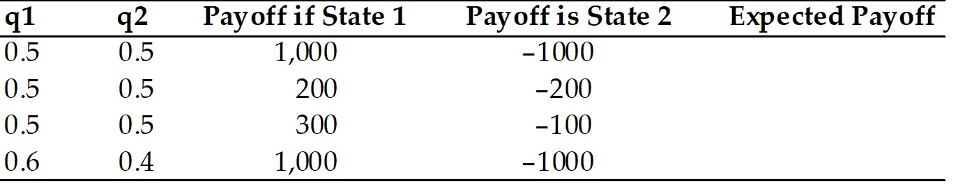

Answer:
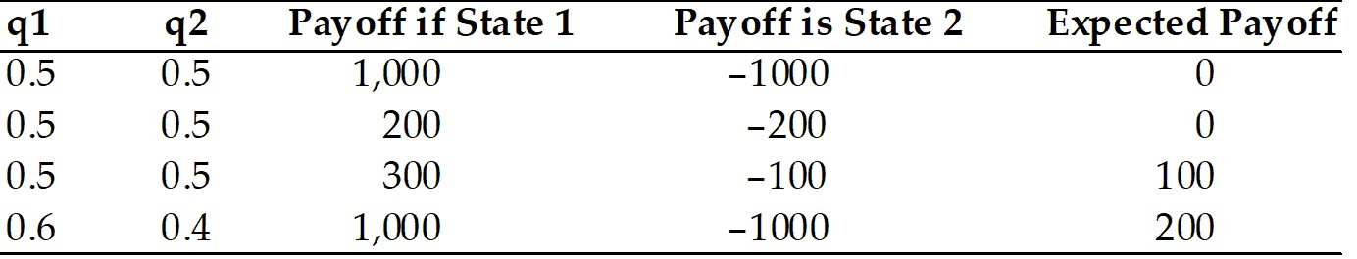

Difficulty: Easy
AACSB: Analytical thinking

37) Calculate the expected payoff for the following cases, where q1 and q2 are the probabilities of state 1 and 2, respectively.

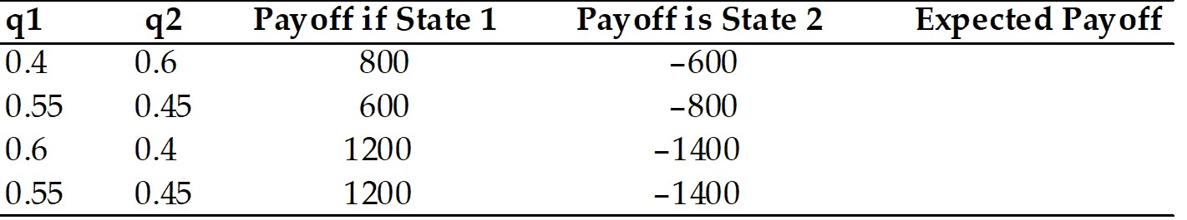

Answer:
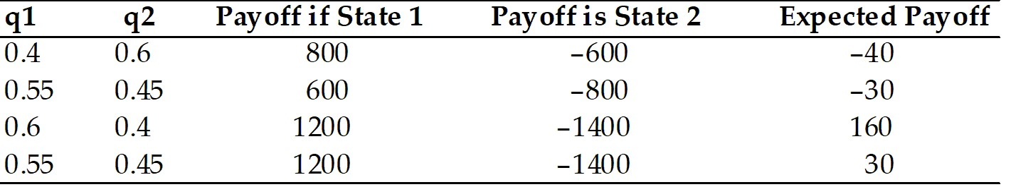

Difficulty: Easy
AACSB: Analytical thinking

38) Complete the following table.

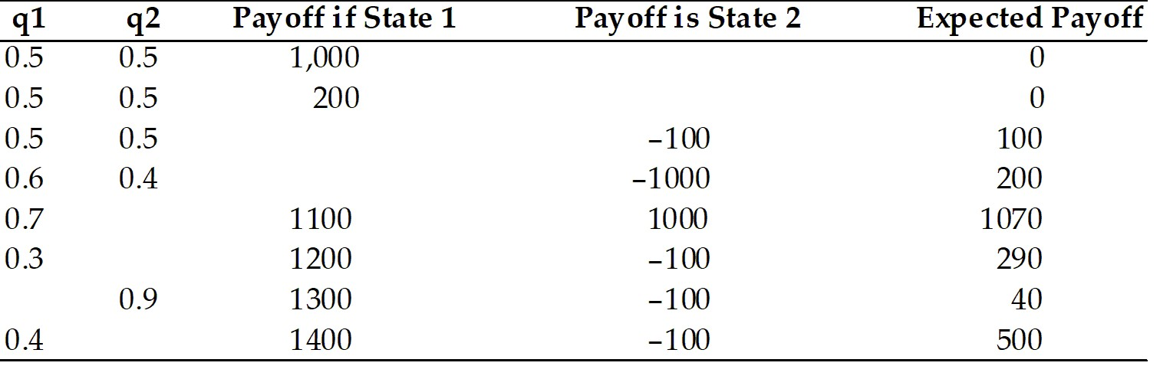

Answer:
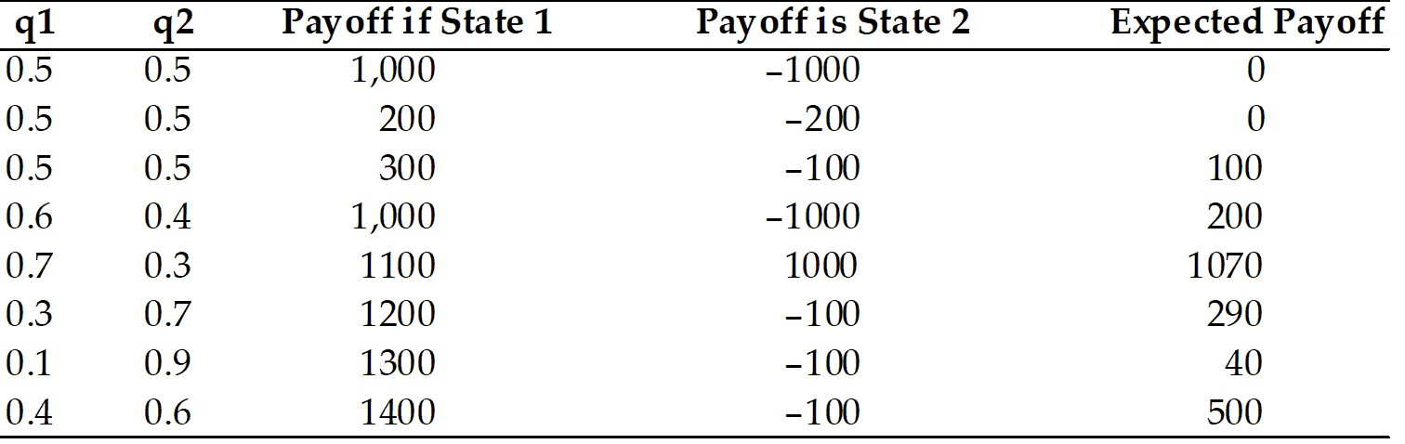

Difficulty: Moderate
AACSB: Analytical thinking

39) Complete the following table.

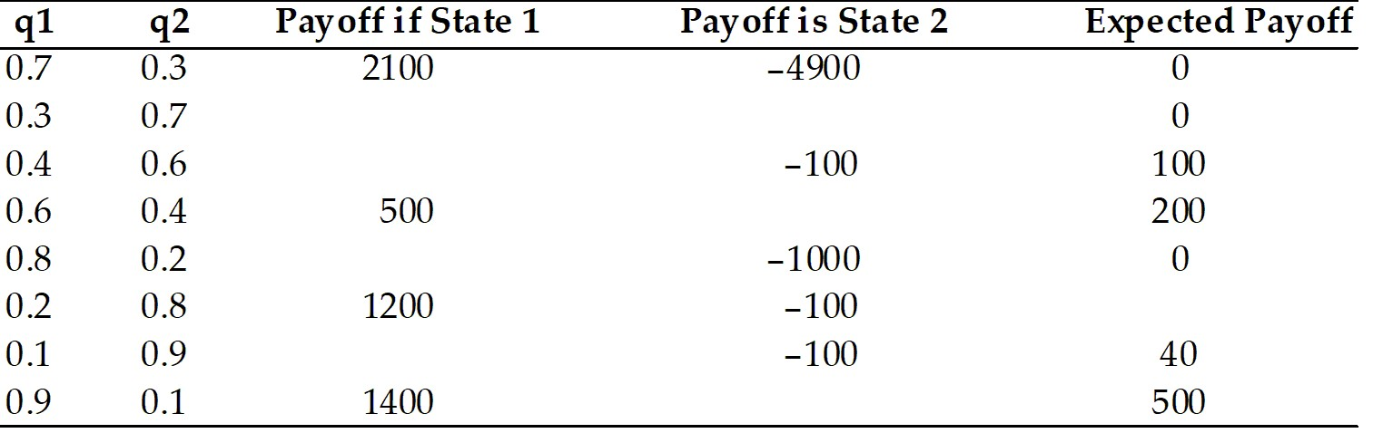

Answer:
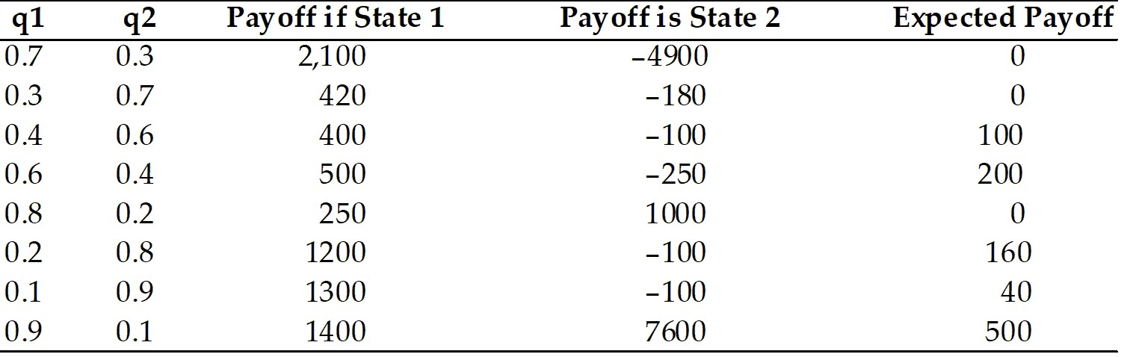

Difficulty: Moderate
AACSB: Analytical thinking

40) Calculate the expected payoff for the following cases with the formula: (P1) * (payoff if state 1) + (P2) * (payoff if state 2), where P1 and P2 are the probabilities of state 1 and 2, respectively.

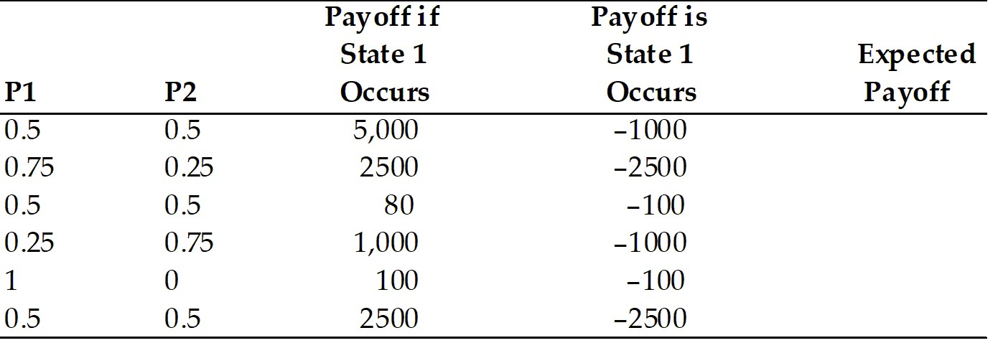

Answer:
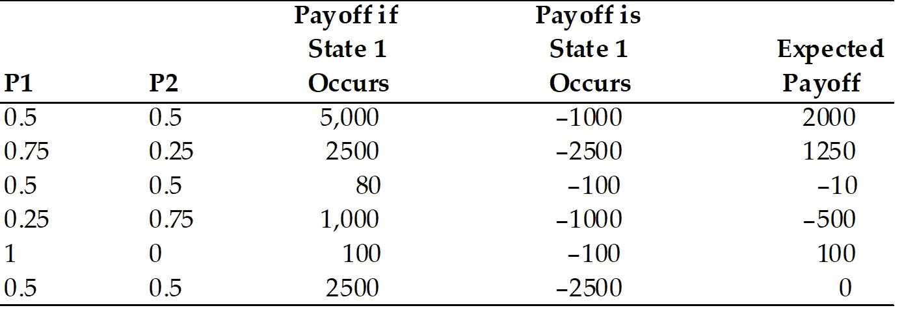

Difficulty: Easy
AACSB: Analytical thinking

41) Complete the following table with the formula (P1) * (payoff if state 1) + (P2)* (payoff if state 2), where P1 and P2 are the probabilities of state 1 and 2, respectively.

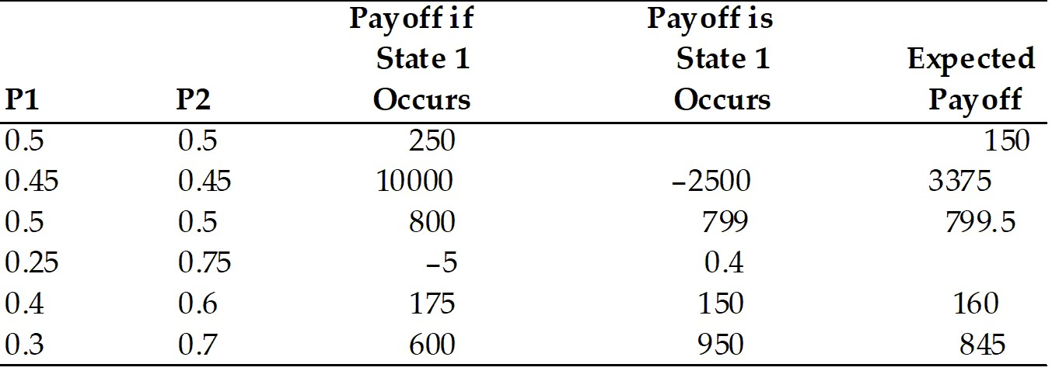

Answer:
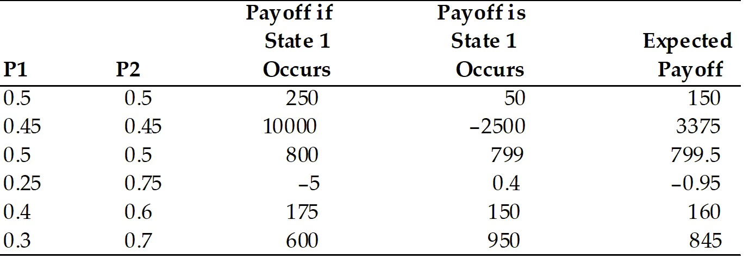

Difficulty: Moderate
AACSB: Analytical thinking

42) Define risk aversion and give an example of a risk-averse person?
Answer: Risk aversion is a characteristic of a person that dislikes risk. An example of this is someone who takes out rental or home insurance to reduce the risk of some kind of catastrophe from happening.
Difficulty: Moderate
AACSB: Application of knowledge

The following simple two-country question illustrates how countries are made better off by trade in assets. Imagine that there are two countries, Home and Foreign, and that residents of each own only one asset, domestic land yielding an annual harvest of kiwi fruit. Assume that the yield on the land is uncertain. Half the time, Home's land yields a harvest of 100 tons of kiwi fruit at the same time as Foreign's land yields a harvest of 50 tons. The other half of the time the outcomes are reversed. The Foreign's harvest is 100 tons, but the Home harvest is only 50.

43) Calculate the average, for each country of kiwi harvest.
Answer: The average for each country of kiwi harvest is: 0.5 ∗ 100 + 0.5 ∗ 50 = 75 tons of kiwi fruit. However, note that the inhabitants of the two countries never know in advance whether the next year will bring feast or famine.
Difficulty: Moderate
AACSB: Application of knowledge

44) Suppose the two countries can trade shares in the ownership of their perspective assets. Further, assume that a Home owner owns a 10 percent share in Foreign land. He will receive 10 percent share in Foreign land, and thus receives 10 percent of the annual Foreign kiwi fruit harvest. Further assume that a Foreign owner of a 10 percent share in Home land is permitted. In this case, a Foreigner is entitled to 10 percent of the Home harvest. Calculate the expected value of kiwi fruit for each investor. Is the investor better off?
Answer: Good year at Home: the farmer will get 90 toms of kiwi from home and 5 tons of kiwi from Foreign. Bad years at home: he will get 45 tons of kiwi from his Home and 10 tons from the Foreign country, namely 55 tons. The probability for a good or a bad year is 0.5. Thus the expected returns will now be:
0.5 ∗ 95 + 0.5 ∗ 55 = 75
It is not clear whether the investor is better off or not. If he likes to smooth his consumption, he may be better off. Otherwise, it is impossible to tell without a particular utility function.
Difficulty: Difficult
AACSB: Application of knowledge

45) Suppose the two countries can trade shares in the ownership of their perspective assets. Further assume that a Home owner owns a 25 percent share in Foreign land. He will receive 25 percent share in Foreign land and thus receives 25 percent of the annual Foreign kiwi fruit harvest. Further assume also that a Foreign owner of a 25 percent share in Home land is permitted. In this case, a Foreigner is entitled to 25 percent of the Home harvest. Calculate the expected value of kiwi fruit for each investor.
Answer: Good year at Home: 75 + 12.5 = 87.5 tons with probability 0.5
Bad year at Home: 37.5 from Home and 25 from Foreign = 62.5 with probability 0.5.
The expected return is: 0.5 ∗ 87.5 + 0.5 ∗ 62.5 = 75.
Difficulty: Difficult
AACSB: Application of knowledge

46) Suppose the two countries can trade shares in the ownership of their perspective assets without any restrictions. Assume that the consumers in both countries would like to totally smooth their consumption. Describe the outcomes.
Answer: In this case, Home residents will buy a 50 percent share of the land in Foreign, and they will pay for it by giving Foreign residents a 50 percent share in Home land. Explain why. To understand why, think about the returns to the Home and Foreign portfolios when both are equally divided between titles to Home and Foreign land. When times are good at Home (and therefore bad in Foreign), each country earns the same return harvest, which is 75 every year with certainty.
Half of the Home harvest (100 ton of kiwi fruit) plus half of the Foreign harvest (50 tons of kiwi fruit) or 75 tons of fruit.
0.5 ∗ 100 + 0.5 ∗ 500 = 75.
In the opposite case-bad times in Home, good time in Foreign-each country still earns 75 tons of fruit.
Thus, we have shown that if the countries hold portfolios equally divided between the two assets, each country earns a certain return of 75 tons of kiwi fruit. This certain return is exactly the same as the average harvest each faced before international asset trade was allowed. This trade completely eliminates the risk faced by both countries without changing average returns. Assuming risk-averse individuals in both countries, the two countries are better off as a result of asset trade.
Difficulty: Difficult
AACSB: Application of knowledge

47) Suppose that trade in asset is not allowed but the two countries sign a treaty that guarantees the sending of 25 tons of kiwi in good time by the high output country in that season. What will the outcome be of such a treaty? Explain why.
Answer: The outcomes will be exactly the same as in Case D above. In other words, rather than signing a treaty, just leaving the financial markets to function will lead us to the desirable results.
Difficulty: Difficult
AACSB: Application of knowledge

48) Why is portfolio diversification so important in international trade?
Answer: Portfolio diversification is important in international trade because parties of the trade are better off by allowing themselves to reduce the risk of the return on their wealth. Traders can divide their wealth among wider amounts of assets in turn reducing the amount of money they have riding on each individual asset.
Difficulty: Moderate
AACSB: Application of knowledge

49) What is the difference between equity instruments and debt instruments?
Answer: Equity instruments are shares of stocks. It is defined as a claim to the firm's profit. Debt instruments are bonds and bank deposits. They specify that the issuer of the instrument must repay a fixed value.
Difficulty: Moderate
AACSB: Application of knowledge

20.2 International Banking and the International Capital Market

1) As a country begins to liberalize its capital account, what would you expect to happen to the difference between the interest rates for similar assets in this country and another country with open capital markets?
A) get larger
B) get smaller
C) stay the same
D) It depends on the existing exchange rate.
E) exponential divergence
Answer: B
Difficulty: Moderate
AACSB: Application of knowledge

2) What structures make up the international capital markets?
A) stock market, IFM, and the World bank
B) bond market, foreign exchange rates, IFM, and the World bank
C) commercial banks, corporations, non-bank financial institutions, the central banks, and other government agencies
D) commercial banks and corporations
E) the central banks and non-bank financial institutions
Answer: C
Difficulty: Easy
AACSB: Application of knowledge

3) ________ are at the center of the international capital market. They run international payments mechanism and a broad range of financial activities.
A) Commercial banks
B) Corporations
C) Nonbank financial institutions
D) Central banks
E) Government agencies
Answer: A
Difficulty: Easy
AACSB: Application of knowledge

4) Corporations routinely finance their investments to obtain foreign sources of funds in the international capital market including
A) selling shares of stocks and debt financing.
B) opening subsidiaries in foreign countries.
C) increasing the domestic and foreign market shares.
D) hiring more foreign employees.
Answer: A
Difficulty: Easy
AACSB: Application of knowledge

5) Investment banks in the U.S. are
A) regular banks specializing in investment projects.
B) not banks at all but institutions which specialize in underwriting sales of stocks and bonds.
C) special arm of the U.S. government for U.S. banks operating outside the U.S.
D) regular banks specializing in investment projects, but allowed to offer limited domestic transactions.
E) international banks that are heavily invested in the U.S.
Answer: B
Difficulty: Easy
AACSB: Application of knowledge

6) Credit Suisse, Goldman Sachs, and Lazard Freres are examples of
A) commercial banks.
B) corporations.
C) non-bank financial institutions, such as insurance companies, pension funds, and mutual funds.
D) central banks and other government agencies.
E) non-profit organizations.
Answer: C
Difficulty: Easy
AACSB: Application of knowledge

7) Which type of main institution in the international capital market most often is involved in foreign exchange intervention?
A) central banks
B) non-bank financial institutions
C) insurance companies
D) corporations
E) commercial banks
Answer: A
Difficulty: Easy
AACSB: Application of knowledge

8) The scale of transactions in the international capital market has
A) grown more quickly than world GDP since the early 1970s.
B) grown less quickly than world GDP since the early 1970s.
C) grown about the same rate as the world GDP since the early 1970s.
D) been fixed by international regulations.
E) decreased more quickly than world GDP since the early 1970s.
Answer: A
Difficulty: Easy
AACSB: Application of knowledge

9) A business's use of a bank located outside of the home country is called
A) offshore banking.
B) international banking.
C) domestic banking.
D) international swapping.
Answer: A
Difficulty: Easy
AACSB: Application of knowledge

10) What are the types of institution banks used to conduct foreign business?
A) corporations
B) central banks
C) commercial banks
D) agency offices, subsidiary banks, and foreign branches
E) state-owned enterprises
Answer: D
Difficulty: Easy
AACSB: Application of knowledge

11) Offshore banking can take place at which institution?
A) agency office only
B) subsidiary bank only
C) foreign bank only
D) subsidiary bank and foreign bank
E) agency office, subsidiary bank, and foreign branch
Answer: E
Difficulty: Easy
AACSB: Application of knowledge

12) The difference between an agency office located abroad and a subsidiary bank located abroad is
A) an agency office is just a home bank in another country, while a subsidiary bank is controlled by a foreign bank and subject to the same regulations as local banks.
B) an agency office is just a home bank in another country, while a subsidiary bank arranges loans and transfers funds but does not accept deposits.
C) an agency office arranges loans and transfers funds but does not accept deposits, while a subsidiary bank is controlled by a foreign bank and subject to the same regulations as local banks.
D) an agency office arranges loans and transfers funds but does not accept deposits, while a subsidiary bank is just a home bank in a foreign country.
E) an agency office is controlled by a foreign bank and subject to the same regulations as local banks, while a subsidiary bank arranges loans and transfers funds but does not accept deposits.
Answer: C
Difficulty: Easy
AACSB: Application of knowledge

13) A bank deposit denominated in a currency other than that of the country in which the bank resides is called
A) an offshore deposit.
B) an onshore deposit.
C) an overseas deposit.
D) a foreign deposit.
Answer: A
Difficulty: Easy
AACSB: Application of knowledge

14) Which one of the following possibilities is TRUE?
A) Much of eurocurrency trading occurs in Europe.
B) Much of eurocurrency trading occurs in the United States.
C) Eurocurrencies trading occurs everywhere except the United States.
D) Eurocurrencies trading occurs everywhere except Europe.
E) Eurocurrencies trading occurs everywhere except China.
Answer: C
Difficulty: Moderate
AACSB: Application of knowledge

15) Eurodollars are
A) dollar deposits located in the United States.
B) dollar deposits located in Europe.
C) dollar deposits located outside Europe.
D) dollar deposits located outside the United States.
E) dollar deposits located outside both Europe and the United States.
Answer: D
Difficulty: Easy
AACSB: Application of knowledge

16) Eurobanks are
A) all European Banks.
B) all non American banks.
C) banks that accept deposits denominated in Eurocurrencies excluding Eurodollars.
D) banks that accept deposits denominated in Eurocurrencies including Eurodollars.
E) banks that do not take U.S. dollars.
Answer: D
Difficulty: Easy
AACSB: Application of knowledge

17) The leading center of Eurocurrency trading is
A) New York City.
B) Chicago.
C) London.
D) Paris.
E) Frankfurt.
Answer: C
Difficulty: Easy
AACSB: Application of knowledge

18) Besides world trade growth, what can explain the growth of international banking since the 1960s?
A) war in the Middle East
B) government focus on banking regulation
C) an increase in world travel
D) the emergence of developing countries like China
E) desire of depositors to hold currencies outside the jurisdiction of the countries that issue them
Answer: E
Difficulty: Easy
AACSB: Application of knowledge

19) Regulatory asymmetries can explain why the following places have become main Eurocurrency centers
A) the United States.
B) Germany.
C) Zurich, Somalia, and Mozambique.
D) London, Luxembourg, and The United States.
E) London, Luxembourg, and Hong Kong.
Answer: E
Difficulty: Moderate
AACSB: Application of knowledge

20) Discuss why commercial banks are at the center of the international capital market.
Answer: Commercial banks are at the center of the international capital market, not only because they run the international payments mechanism but also because of the broad range of financial activities they undertake. Bank liabilities consist chiefly of deposits of various maturities, as well as debt and short-term borrowing from other financial institutions, while their assets consist largely of loans (to corporations and governments), deposits at other banks (interbank deposits), and various securities including bonds. Multinational banks are also heavily involved in other types of asset transaction. For example, banks may underwrite issues of corporate stocks and bonds by agreeing, for a fee, to find buyers for those securities at a guaranteed price.
Difficulty: Moderate
AACSB: Application of knowledge

21) Give an example of regulatory asymmetry in international banking? How did it affect the growth of international banking over the past 50 years?
Answer: Commercial banks are often free to pursue activities abroad that they could not legally pursue in their home countries. This type of regulatory asymmetry has spurred the growth of international banking over the past 50 years.
Another example of regulatory asymmetry is the shadow banking system (money market mutual funds, investment banks, etc). The shadow banking system has grown dramatically and taken up many of the same functions as traditional banking. They have been minimally regulated compared to banks.
Difficulty: Easy
AACSB: Application of knowledge

22) Describe the role of offshore banking and of offshore currency (eurocurrencies) trading.
Answer: Both have mushroomed due to increased international trade, increased multinational corporations and globalization. Students should also emphasize banks' desire to escape domestic government regulations and taxes on financial activities and political concerns from holding deposits in the country that issued them, which increases default concerns on the part of the foreign investors, etc.
Difficulty: Moderate
AACSB: Application of knowledge

23) Describe at least one major factor that contributed to the growth of international capital market since the early 1970s.
Answer: In the industrial world, countries have progressively dismantled barriers to private capital flows across their borders. The widespread adoption of flexible exchange rates since the early 1970s has allowed countries to reconcile open capital markets with domestic monetary autonomy.
Difficulty: Easy
AACSB: Application of knowledge

24) Explain the growth of international banking since the 1960s.
Answer: Besides world trade growth, another factor is the banks' desire to escape domestic government regulations on financial activity (and sometimes taxes) by shifting some of their operations abroad and into foreign currencies. A further factor is in part political: the desire by some depositors to hold currencies outside the jurisdictions of the countries that issue them.
Difficulty: Easy
AACSB: Application of knowledge

25) Explain why a London Eurobank has a competitive advantage over a bank in New York in attracting dollar deposits.
Answer: It can pay more because the London bank is not subject to any reserve requirements (neither American nor British), whereas the New York bank is subject to U.S. reserve requirements.
Difficulty: Moderate
AACSB: Application of knowledge

26) Explain what Eurocurrencies are and why they are significant.
Answer: Eurocurrencies are offshore currency deposits denominated in a currency other than that of the country in which the bank resides. This currency is significant because of the rapid expansion of international trade and increased multinational nature of corporations' activities.
Difficulty: Moderate
AACSB: Application of knowledge

20.3 Banking and Financial Fragility

1) Which of the following statements is NOT true regarding a bank failure?
A) A bank fails when its profit is much lower and it is unable to compete with other local banks.
B) A bank fails when it is unable to meet its obligations to its depositors and other creditors.
C) A bank fails when it is unable to repay its short-term liabilities, including demand deposits without notice.
D) A bank fails when some of the bank's borrowers are unable to repay their loans or the bank's assets decline in value for some other reason.
E) A bank fails when faced with a large and sudden loss of deposits — a bank run.
Answer: A
Difficulty: Easy
AACSB: Application of knowledge

2) A bank faced with a large and sudden loss of deposits is likely to shut down despite a fundamentally sound balance sheet. Why could this be?
A) Banks have accountants that are too optimistic.
B) Banks purposely lie about their balance sheets in order to attract more clients.
C) Many bank assets are illiquid and cannot be sold quickly to meet deposit obligations without substantial loss to the bank.
D) Many banks operate on a budget that exceeds their actual reserves.
E) Many banks will shut down to preserve their interest profits.
Answer: C
Difficulty: Moderate
AACSB: Application of knowledge

3) Which of the following statements is TRUE?
A) Bank failure is limited to banks that have mismanaged their assets.
B) Bank failure is limited to banks that have invested in real estate.
C) Bank failure is limited to banks that have invested in government bonds.
D) Bank failure is limited to a few banks.
E) Bank failure is NOT limited to banks that have mismanaged their assets.
Answer: E
Difficulty: Easy
AACSB: Application of knowledge

4) The difference between assets and liabilities or the amount the bank could lose on its assets before it becomes unable to pay off its debts by selling its assets is called
A) bank capital.
B) bank failure.
C) bank run.
D) bank balance.
Answer: A
Difficulty: Easy
AACSB: Application of knowledge

5) The ________ a bank's capital, the ________ chance it becomes insolvent due to losses in asset values.
A) lower; higher
B) lower; lower
C) higher; higher
D) higher; same
Answer: A
Difficulty: Easy
AACSB: Application of knowledge

6) Which of the following statements is TRUE?
A) Bank failures inflict serious financial harm on individual depositors.
B) Bank failures do not inflict serious financial harm on individual depositors.
C) Bank failures inflict not only serious financial harm on individual depositors, but also harm the macroeconomic stability of the economy.
D) Bank failures inflict serious financial harm on individual depositors, but fortunately do not harm the macroeconomic stability of the economy.
E) Bank failures only inflict serious financial harm on the macroeconomic stability of the economy.
Answer: C
Difficulty: Easy
AACSB: Application of knowledge

7) In the United States, which of the following safety precautions has the government NOT taken to reduce Bank failures?
A) implemented deposits insurance
B) bank reserve requirements
C) capital requirements and asset restrictions
D) required bank examination
E) forcibly closing poorly run banks
Answer: E
Difficulty: Moderate
AACSB: Application of knowledge

8) Which of the following statements is TRUE for the U.S.?
A) The Federal Deposit Insurance Corporation (FDIC) insures bank deposits against losses up to $250,000.
B) The Federal Deposit Insurance Corporation (FDIC) insures bank deposits against losses up to $100,000.
C) The Federal Deposit Insurance Corporation (FDIC) insures bank deposits against losses up to $10,000.
D) The Federal Deposit Insurance Corporation (FDIC) insures bank deposits against natural disaster up to $100,000.
E) The Federal Deposit Insurance Corporation (FDIC) insures bank deposits against floods up to $100,000.
Answer: A
Difficulty: Easy
AACSB: Application of knowledge

9) Which of the following statements is TRUE for the U.S.?
A) The FDIC does not provide insurance for deposits for Savings and Loans (S&L) associations.
B) The FDIC does provide insurance for deposits for Savings and Loans (S&L) associations, but only up to $50,000.
C) The FDIC does provide insurance for deposits for Savings and Loans (S&L) associations up to $250,000.
D) The FDIC does provide insurance for deposits for Savings and Loans (S&L) associations up to $150,000.
E) The FDIC does provide insurance for deposits for Savings and Loans (S&L) associations up to $100,000.
Answer: C
Difficulty: Easy
AACSB: Application of knowledge

10) Banks in the U.S.
A) face rules against lending too large a fraction of their assets to a single private customer only.
B) face rules against lending too large a fraction of their assets to a single private customer or to a single foreign government borrower.
C) face rules against lending too large a fraction of their assets to a single foreign government borrower only.
D) face rules against lending to too many foreign organizations and corporations.
E) face rules against lending to other banks.
Answer: B
Difficulty: Easy
AACSB: Application of knowledge

11) Banks in the U.S.
A) cannot hold common stocks.
B) can hold common stocks.
C) cannot hold common stocks of companies they do business with.
D) cannot hold common stocks of companies that have their headquarters in the same state.
E) can hold risky assets.
Answer: A
Difficulty: Easy
AACSB: Application of knowledge

12) Banks in the U.S.
A) are prevented from holding assets that are "too risky."
B) are not prevented from holding assets that are "too risky."
C) are encouraged not to hold assets that are "too risky."
D) are not encouraged not to hold assets that are "too risky."
E) are encouraged to lend to a single private customer.
Answer: A
Difficulty: Easy
AACSB: Application of knowledge

13) Government supervisors such as a central bank or a separate financial supervision authority
A) have the right to examine a bank's books to ensure compliance with bank capital standards and other regulations.
B) pay off loans that banks are unable to pay.
C) help manage bank over the crisis.
D) insure bank depositors against losses.
Answer: A
Difficulty: Easy
AACSB: Application of knowledge

14) In the U.S., banks
A) cannot be forced to sell assets that the bank examiner deems too risky.
B) can be forced to sell assets that the bank examiner deems too risky.
C) can be forced to sell assets that the bank examiner deems too risky only after a court order.
D) can be forced to sell assets that the bank examiner deems too risky only after both examiners from the Fed and from the FDIC agree.
E) can be forced to trade assets that the bank examiner deems too risky.
Answer: B
Difficulty: Easy
AACSB: Application of knowledge

15) In the U.S., banks
A) may not be forced by bank examiner to adjust their balance sheets by writing off loans the examiner thinks will not be repaid.
B) may be forced by bank examiner to adjust their balance sheets by writing off loans the examiner thinks will not be repaid.
C) may be forced by bank examiner to adjust their balance sheets by writing off loans the examiner thinks will not be repaid only if the Fed and the FDIC examiners agree.
D) may be forced by bank examiner to adjust their balance sheets by writing off loans the examiner thinks will not be repaid only if the Fed and the Office of the Comptroller of the Currency examiners agree.
E) may be forced by bank examiner to adjust their balance sheets by paying off loans the examiner thinks will not be repaid.
Answer: B
Difficulty: Easy
AACSB: Application of knowledge

16) U.S. reserve requirements
A) are rejected by half the banks operating in the United States.
B) show how regulatory asymmetries can operate to enhance the profitability of Eurocurrency trading.
C) tend to harm the bank's business and decrease monetary aggregates.
D) force banks to hold a portion of its assets in a liquid form easily mobilized to meet sudden deposit outflows.
E) remain in place, but capital requirements have begun defaulting.
Answer: D
Difficulty: Easy
AACSB: Application of knowledge

17) When a central bank lends to banks facing massive deposit outflows as much as they need to satisfy their depositors' claims, it is acting as a ________ to safeguard against financial panic conditional on the bank's sound management.
A) lender of last resort
B) life saver
C) problem solver
D) risk taker
Answer: A
Difficulty: Easy
AACSB: Application of knowledge

18) The case where people purposely act in a careless way, for example, driving recklessly because they are insured, is called
A) asymmetric information.
B) risk aversion.
C) moral hazard.
D) bounded rationality.
E) thrill-seeking.
Answer: C
Difficulty: Easy
AACSB: Application of knowledge

19) The ________ that results from a combination of perceived government guarantees and weak regulations of the guaranteed institutions has helped fuel excessively speculative investment in many economies.
A) moral hazard
B) risk aversion
C) asymmetric information
D) bounded rationality
E) thrill-seeking
Answer: A
Difficulty: Easy
AACSB: Application of knowledge

20) What is "too big to fail" policy?
A) It is a government's policy to protect big banks when they get into trouble because their failures may set off a chain reaction that throws the entire financial system into crisis.
B) It is a government's policy to prevent small and medium sized banks from becoming too big to get into trouble.
C) It is a government's policy to make banks become more interconnected so that their creditors can be fully protected.
D) It is a government's policy to avoid a vicious circle of moral hazard to stabilize the financial system.
Answer: A
Difficulty: Easy
AACSB: Application of knowledge

21) Many observers believe that the largely unregulated nature of global banking activity leaves the world financial system vulnerable to bank failure on a massive scale. Is this a real threat? If so, what measures have governments taken to reduce it?
Answer: Yes, this is a real threat. A high level of inter-bank depositing implies that problems affecting a single bank could be highly contagious and could spread quickly to banks with which it is thought to do business. In response to this threat, the Basel Committee was created in 1974 to coordinate the surveillance and regulation among bank regulators from different countries.
Difficulty: Moderate
AACSB: Application of knowledge

22) "Bank failure may not be limited to banks that have mismanaged their assets." Explain why?
Answer: A sound bank faced with the wholesale loss of deposits is likely to close its door even if the asset side of its balance sheet is fundamentally sound because many bank assets are illiquid and cannot be sold quickly to meet deposit obligations without substantial loss to the bank. Students should stress the atmosphere of financial panic, which will lead to self-fulfilling expectations.
Difficulty: Moderate
AACSB: Application of knowledge

23) "It is in the interest of each depositor to withdraw her money from a bank if all other depositors are doing the same, even when the bank's assets are sound." Discuss. As part of your answer clearly state whether the statement is true or false.
Answer: True. Students should elaborate on bank run and stress the atmosphere of financial panic, which will lead to self-fulfilling expectations.
Difficulty: Moderate
AACSB: Application of knowledge

24) "There is evidence that the string of U.S. bank closings in the early 1930s helped start and worsen the Great Depression." Discuss.
Answer: Bank failure can harm the economy's macroeconomic stability (keep in mind that safeguards intended to reduce the risk of bank failure were put in place after the Great Depression). One bank's problems may spread to sounder banks if they are suspected of having lent to the bank in trouble. This leads to a drastic reduction in the banking system's ability to finance investment and consumer-durable expenditure, so the economy slips into recession (or worse in the case of the Great Depression).
Difficulty: Moderate
AACSB: Application of knowledge

25) Describe the extensive "safety net" that has been set up in the United States in order to reduce the risk of bank failure.
Answer: (1) Deposit insurance
(2) Reserve requirements
(3) Capital requirements and asset restrictions
(4) Bank examination
(5) Lender of last resort facilities
Difficulty: Moderate
AACSB: Application of knowledge

26) What is moral hazard and how to avoid it?
Answer: The possibility that someone who is insured against an accident will take less care to prevent it is called moral hazard. Domestic bank supervision and balance-sheet restrictions are necessary to limit the moral hazard resulting from deposit insurance and access to the lender of last resort, which otherwise would lead banks to make excessively risky loans and inadequate provision for their possible failure.
Difficulty: Easy
AACSB: Application of knowledge

27) Explain why the FDIC is following a "too-big-to-fail" policy of fully protecting all depositors at the largest banks.
Answer: A tricky question. The FDIC does that although, officially, it still applies only to the $250,000 limit. Probably, the idea is that the cost to one depositor is unbearable relative to the small cost we all need to pay as a collective. Also, there are the issues of political pressure and avoiding blaming the government for mismanaging the safeguards.
Difficulty: Moderate
AACSB: Application of knowledge

28) Why are economists increasingly in favor of curbs on the size of financial firms instead of "too big to fail" policy?
Answer: When a financial institution is "too big to fail" or "too interconnected to fail"–its managers and creditors expect that the government will have no choice but to support it in case it gets into trouble. The resulting moral hazard sets off a vicious circle of firms getting bigger, more profit, more growth, and more moral hazard; therefore makes the entire financial system becomes less stable. For this reason, economists are increasingly in favor of curbs on the size of financial firms despite the possible sacrifice of scale efficiencies. They favor forcing large complex banks and shadow banks to be closed and wound down, in case of insolvency, with minimal disruption and minimal cost to taxpayers. The credible threat of bank closure is necessary for limiting moral hazard–bank managers need to know they can be put out of business if they misbehave–but devising concrete procedures is not easy, especially in an international context.
Difficulty: Easy
AACSB: Application of knowledge

20.4 How Well Have International Financial Markets Allocated Capital and Risk?

1) What is a difficulty encountered in regulating international banking?
A) excessive deposit insurance rates on international banks
B) absence of overseas reserve requirements
C) oppressive regulatory controls that reduce competitiveness
D) lack of funds and incentive to secure payments
E) variability in exchange rates
Answer: B
Difficulty: Moderate
AACSB: Application of knowledge

2) The process of banks shifting risky business that home regulators might question to regulatory jurisdictions where fewer questions are asked is called
A) regulatory arbitrage.
B) regulatory asymmetry.
C) regulatory shifting.
D) regulatory capture.
Answer: A
Difficulty: Easy
AACSB: Application of knowledge

3) A financial trilemma constrains what policy makers in an open economy can achieve. At most two goals from the following list of three are simultaneously feasible
A) financial stability, national control over financial safeguard policy, freedom of international capital movements.
B) financial security, fiscal decentralization, system scalability.
C) national sovereignty, democracy, and globalization economic integration.
D) independent monetary policy, fixed exchange rate, freedom of international capital movements.
Answer: A
Difficulty: Easy
AACSB: Application of knowledge

4) The purpose of the Basel Committee was to
A) achieve a better coordination of the surveillance exercised by national authorities over the international banking system.
B) achieve a better coordination of domestic banking systems.
C) achieve a better coordination between brokers and investment bankers.
D) achieve a better coordination between bond holder and bond issuers.
E) manipulate bank rates for more leverage profits.
Answer: A
Difficulty: Moderate
AACSB: Application of knowledge

5) The Basel Committee was set up in 1974 to
A) strengthen the regulation, supervision and practices of banks worldwide with the purpose of enhancing financial stability.
B) achieve a better coordination of domestic banking systems.
C) strengthen coordination between brokers and investment bankers.
D) achieve a better coordination between bond holder and bond issuers.
E) manipulate bank rates for more leverage profits.
Answer: A
Difficulty: Easy
AACSB: Application of knowledge

6) The Basel committee
A) takes advantages of loopholes in multinational banks.
B) does not support regulatory agencies that monitor the assets of banks' foreign subsidiaries.
C) submitted its Concordat in 1975 and was then disbanded.
D) continues to be the major forum for cooperation in the regulation of international banking.
E) met for the first time in 1975.
Answer: D
Difficulty: Easy
AACSB: Application of knowledge

7) Capital markets of poor developing countries that liberalized their financial systems to allow private asset trade with foreigners are called
A) direct foreign markets.
B) foreign exchange markets.
C) stock & bond markets.
D) emerging markets.
E) fledgling financial markets.
Answer: D
Difficulty: Easy
AACSB: Application of knowledge

8) Which statement is NOT true regarding emerging markets?
A) Emerging market financial institutions have generally proven to be weaker than those in industrialized countries.
B) Emerging markets are the capital markets of poorer, developing countries that have liberalized their financial system to allow private asset trade with foreigners.
C) Countries with emerging markets include Brazil, Mexico, and Thailand.
D) Countries with emerging markets have been unable to liberalize their financial systems to allow private trade with foreigners.
E) Emerging market financial institutions contributed to the financial crisis of 1997-1999.
Answer: D
Difficulty: Easy
AACSB: Application of knowledge

9) What is an appropriate definition for "securitization"?
A) the repackaging of bank assets into readily marketable forms
B) the promise of a secure return on deposits in FDIC banks
C) the simplification of interest-bearing assets into their simplest derivative form
D) the unloading of derivative securities in response to a bank run
E) the reinforcement of an asset's worth through official certification
Answer: A
Difficulty: Easy
AACSB: Application of knowledge

10) What caused a major economic shock in August 2007?
A) U.S. mortgage market
B) war in Iraq
C) U.S. bond market
D) technology stocks
E) misreporting from Asian markets
Answer: A
Difficulty: Easy
AACSB: Application of knowledge

11) The severity and breadth of the 2007—2009 crisis have led to initiatives to reform both national financial systems and the international system in order to
A) fill gaps in existing regulatory frameworks while also paying more attention to the macroeconomic causes and consequences of banking problems.
B) avoid financial crisis permanently in the future.
C) make it easy for banks to get around capital requirements.
D) to set up an omniscient global financial authority responsible for monitoring and regulating the systems.
Answer: A
Difficulty: Easy
AACSB: Application of knowledge

12) ________ was proposed in 2010 as a tougher set of capital standards and regulatory safeguards for international banks.
A) Basel III
B) Basel II
C) Basel I
D) FSB
Answer: A
Difficulty: Easy
AACSB: Application of knowledge

13) In April 2009, Financial Stability Board was established to
A) monitor the global financial system and make recommendations for global policy coordination and reform.
B) implement Base III recommendations.
C) regulate systemically important nonbank financial institutions.
D) eliminate the problem of "too big to fail."
Answer: A
Difficulty: Easy
AACSB: Application of knowledge

14) The macroprudential perspective on financial regulation seeks
A) to ensure the financial system as a whole is sound.
B) to ensure that each individual financial institution is sound and that is enough.
C) to make each individual institution more resilient without worrying about the whole system.
D) to reduce moral hazard in the financial markets.
Answer: A
Difficulty: Easy
AACSB: Application of knowledge

15) National financial regulators often face fierce lobbying from their home financial institutions, which argue that
A) stricter rules would put them at a disadvantage relative to foreign rivals.
B) stricter rules would give them an advantage relative to foreign rivals.
C) stricter rules would have no effect on their disadvantage relative to foreign rivals.
D) stricter rules would put home institutions and foreign rivals on an equal and fair playing field.
Answer: A
Difficulty: Easy
AACSB: Application of knowledge

16) Describe the financial trilemma for international policy makers.
Answer: The difficulties in regulating international financial institutions show that a financial trilemma constrains what policy makers in an open economy can achieve. At most two goals from the following list of three are simultaneously feasible:
1. Financial stability.
2. National control over financial safeguard policy.
3. Freedom of international capital movements.
Difficulty: Easy
AACSB: Application of knowledge

17) Explain why an international banking system is harder to regulate than a national system.
Answer: Students can look at how the effectiveness of the U.S. safeguards is reduced owing to offshore banking activities covered in the textbook and during the lecture.
(1) No deposit insurance, in particular, inter-bank deposits are unprotected
(2) Absence of reserve requirements
(3) Bank examination more difficult to enforce
(4) Not clear which group of regulators has responsibility for monitoring a given bank's assets
(5) Not clear which central bank, if any, is responsible for providing Lender of Last Resort assistance.
Difficulty: Moderate
AACSB: Application of knowledge

18) "The internationalization of banking has weakened national safeguards against banking collapse, but at the same time it has made the need for effective safeguards more urgent." Discuss.
Answer: True. Students should elaborate on:
(1) No deposit insurance, in particular, inter-bank deposits are unprotected
(2) Absence of reserve requirements
(3) Bank examination more difficult to enforce
(4) Not clear which group of regulators has responsibility for monitoring a given bank's assets
(5) Not clear which central bank, if any, is responsible for providing Lender of Last Resort assistance.
Difficulty: Moderate
AACSB: Application of knowledge

19) Explain the difficulties in regulating international banking.
Answer:
(1) No deposit insurance, in particular, inter-bank deposits are unprotected
(2) Absence of reserve requirements
(3) bank examination more difficult to enforce
(4) not clear which group of regulators has responsibility for monitoring a given bank's assets
(5) not clear which central bank, if any, is responsible for providing Lender of Last Resort assistance.
Difficulty: Moderate
AACSB: Application of knowledge

20) Explain the issues involved with the Fed acting as a Lender of Last Resort (LLR).
Answer: On the one hand, LLR enables the Fed to avoid panic and disturbance to proper functioning of financial markets. On the other hand, using the policy may cause problems of moral hazard.
Difficulty: Moderate
AACSB: Application of knowledge

21) Who is the Basel Committee? Discuss both their involvement in the Concordat as well as the role of the Concordat in international banking.
Answer: In 1975, the Basel Committee reached an agreement, called the Concordat, which allocated responsibility for supervising multinational banking establishments. In addition, the Concordat called for the sharing of information about banks and the granting of permission to inspect any such banks.
Difficulty: Moderate
AACSB: Application of knowledge

22) What is securitization?
Answer: The term refers to financial instrument in which bank assets are repackaged in readily marketable forms. This kind of "derivatives," although useful for the international investors and the banks that underwrite them, causes huge problems in government abilities to monitor bank assets and independently assess their risk to the soundness of the international banking system.
Difficulty: Moderate
AACSB: Application of knowledge

23) Explain the source of the global financial crisis of 2007-2009?
Answer: Students can answer based on the case study covered in the textbook and during the lecture.
Difficulty: Easy
AACSB: Application of knowledge

20.5 Metrics for International Capital Market Performance

1) The present structure of the international capital market involves risks of financial instability that can be reduced through all of the following except
A) enhancement of trade barriers.
B) close cooperation of bank and financial supervisors in many countries.
C) portfolio diversification when residents of different countries trade risky assets.
D) innovative way around national regulations that also provide important gains for customers.
E) rapid flow of information about investment opportunities.
Answer: A
Difficulty: Easy
AACSB: Application of knowledge

2) What are three things to measure for in evaluating the performance of the capital markets?
A) level of intertemporal trade, international trade, portfolio diversification
B) level of portfolio diversification, balanced capital accounts, global inflation
C) level of portfolio diversification, intertemporal trade, efficiency of foreign exchange
D) onshore-offshore interest rate parity, level of portfolio diversification, stability of eurocurrency market
E) onshore-offshore interest rate parity, interest parity and foreign exchange, balanced capital accounts
Answer: C
Difficulty: Easy
AACSB: Application of knowledge

3) Investors much prefer to invest in domestic stocks rather than diversifying abroad. This situation is called
A) home bias.
B) foreign bias.
C) domestic bias.
D) national bias.
Answer: A
Difficulty: Easy
AACSB: Application of knowledge

4) Why might a country's savings rate have a high positive correlation to its investment rate?
A) A country's gains from intertemporal trade may have been large.
B) governments' regulation to avoid inflation
C) A country's savings rate and investment rate are generally not positively correlated but rather have negative correlation.
D) governments' regulation to avoid large current account balances
E) A government has not practiced sufficient fiscal regulation.
Answer: D
Difficulty: Easy
AACSB: Application of knowledge

5) From 1990 to 2019, OECD countries' saving and investment ratios to output tend to be
A) positively related.
B) negatively related.
C) completely unrelated.
D) randomly related.
Answer: A
Difficulty: Easy
AACSB: Application of knowledge

6) Large differences in interest rates between countries would indicate that
A) the global market is thriving.
B) there is good communication between countries about potential global investment opportunities.
C) there are unrealized gains from trade.
D) the market is in danger of collapse.
E) the supply growth exceeds the aggregate demand.
Answer: C
Difficulty: Easy
AACSB: Application of knowledge

7) Statistical studies of the relationship between interest rates and later depreciation rates show that
A) the interest difference has been a very bad predictor in the large swings of exchange rates.
B) the interest difference has been an accurate predictor in the large swings of exchange rates.
C) the interest difference has correctly predicted the direction in which exchange rates would change.
D) the interest difference has not yet been studied as a predictor in the large swings of exchange rates.
E) the interest difference is unrelated to the large swings of exchange rates.
Answer: A
Difficulty: Easy
AACSB: Application of knowledge

8) In the Interest Parity Condition, Rt - Rt = (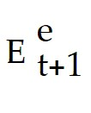 - Et)/Et + xt, where Rt - Rt is the interest rate differential and ( - Et)/Et is the expected change in the exchange rate, what does xt stand for if it potentially is a market efficient difference between the two?
A) market inefficiency
B) risk premium
C) forecast error
D) tracking error
E) excessive volatility
Answer: B
Difficulty: Easy
AACSB: Application of knowledge

9) Departures from interest parity
A) can be explained using theories of risk premium.
B) cannot be explained using theories of risk premium.
C) may or may not be able to be explained using theories of risk premium, more research is needed.
D) are completely unrelated to risk premium.
E) occur when risk premium is over calculated.
Answer: C
Difficulty: Moderate
AACSB: Application of knowledge

10) A random walk model can more accurately predict exchange rates as compared to a sophisticated forecast
A) always.
B) for forecasts up to a year away.
C) for forecasts longer than a year away.
D) never.
E) because of the predictability of exchange rates.
Answer: B
Difficulty: Easy
AACSB: Application of knowledge

11) The exchange rate disconnect puzzle refers to
A) the remarkable weak short-term relationship between the exchange rate and the rest of the economy.
B) the remarkable strong short-term relationship between the exchange rate and the rest of the economy.
C) the remarkable weak long-term relationship between the exchange rate and the rest of the economy.
D) the remarkable strong long-term relationship between the exchange rate and the rest of the economy.
Answer: A
Difficulty: Easy
AACSB: Application of knowledge

12) Which of the following is TRUE about exchange rates?
A) They should not be volatile because they will determine the economic climate.
B) They are generally more volatile than stock prices.
C) They are more volatile than several underlying factors that move them such as money supplies and fiscal variables.
D) They should be volatile because to correct price signals they adjust quickly in response to economic news, but they are generally less volatile than stock prices.
E) They never overreact to economic news.
Answer: D
Difficulty: Moderate
AACSB: Application of knowledge

13) Explain why, according to Feldstein and Horioka, one should expect that domestic investment rates diverge widely from saving rates.
Answer: The decisions of corporations to invest and for households to save are different. Thus globalization means more and different ways to save and invest and increasing the differences between the two ratios.
Difficulty: Moderate
AACSB: Application of knowledge

14) Explain why large interest rate differences would be strong evidence of unrealized gains from trade.
Answer: The difference between onshore and offshore interest rates on similar assets denominated in the same currency should be small if information about global investment opportunities is transmitted efficiently. Data show that this is the case for the U.S., Germany, Japan and the Netherlands.
Difficulty: Moderate
AACSB: Application of knowledge

15) Discuss studies based on the interest parity conditions.
Answer: In general, the formula does not hold and is not a good predictor of future devaluations. Even worse, it failed to predict correctly even the direction in which the spot exchange rate would change.
Difficulty: Moderate
AACSB: Application of knowledge

16) Explain the forecast error, ut+1, in terms of:
(1) Its equation (what it is equal to)
(2) How it is used
(3) Its accuracy
Answer: (Et+1 - Et)/Et - ( - Et)/Et this equation represents actual minus expected depreciation, where ut+1 is the forecast error made in predicting future depreciation.
Under interest parity the equation ((Et+1 - Et)/Et - (Rt - Rt) would also be correct, this equation represents the actual currency depreciation minus the interest difference.
Statistical methods have been used to see if the forecast error is predictable through the use of past information. Indeed, a number of researchers have found that ut+1 CAN be predicted.
Difficulty: Difficult
AACSB: Application of knowledge

17) Does the interest rate parity hold in each of the following cases? In case it does not hold, calculate the risk premium.
A. Rt = 5, 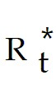 = 3, Et = 5,  = 7
B. Rt = 6,  = 3, Et = 5,  = 7
C. Rt = 7,  = 3, Et = 5,  = 7
D. Rt = 8,  = 3, Et = 5,  = 7
E. Rt = 5,  = 4, Et = 5,  = 7
F. Rt = 5,  = 5, Et = 5,  = 7
G. Rt = 5,  = 6, Et = 5,  = 7
H. Rt = 5,  = 3, Et = 6,  = 7
I. Rt = 5,  = 3, Et = 7,  = 7
J. Rt = 5,  = 3, Et = 8,  = 7
K. Rt = 5,  = 3, Et = 5,  = 8
L. Rt = 5,  = 3, Et = 5,  = 9
M. Rt = 5,  = 3, Et = 5,  = 10

Answer:
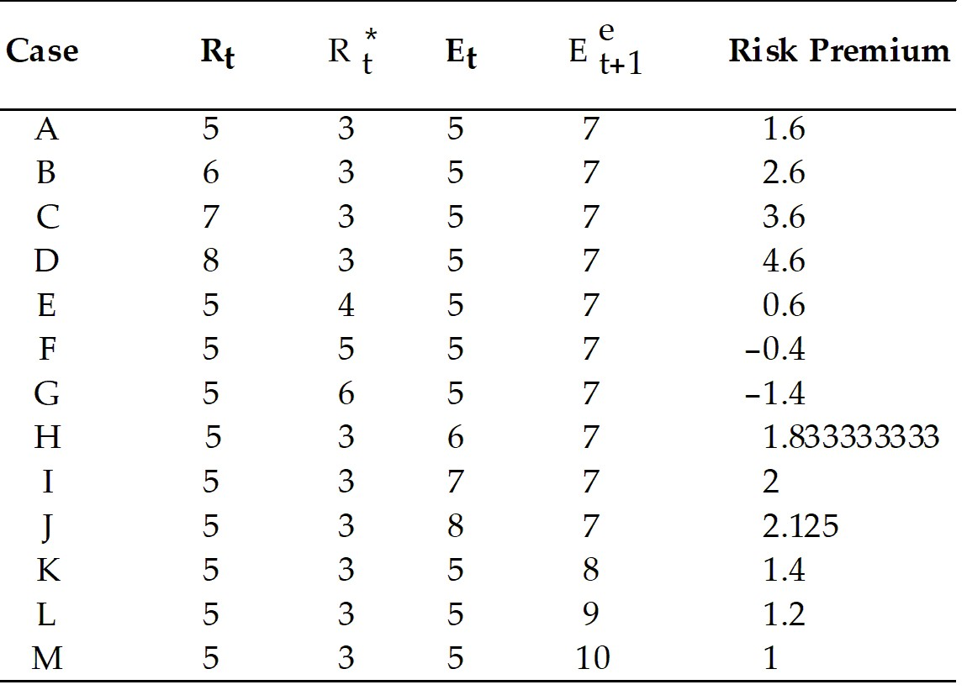

Difficulty: Moderate
AACSB: Application of knowledge

18) Does the interest rate parity hold in each of the following cases? In case it does not hold, calculate the risk premium.
N. Rt = 8,  = 3, Et = 5,  = 7
O. Rt = 7,  = 4, Et = 6,  = 8
P. Rt = 6,  = 5, Et = 5,  = 7
Q. Rt = 5,  = 4, Et = 6,  = 8
R. Rt = 8,  = 6, Et = 5,  = 7
S. Rt = 7,  = 5, Et = 6,  = 8
T. Rt = 6,  = 4, Et = 5,  = 7
U. Rt = 5,  = 3, Et = 6,  = 8
V. Rt = 8,  = 5, Et = 6,  = 8
W. Rt = 7,  = 3, Et = 8,  = 9
X. Rt = 6,  = 7, Et = 7,  = 8
Y. Rt = 5,  = 6, Et = 5,  = 9
Z. Rt = 4,  = 3, Et = 5,  = 10

Answer:
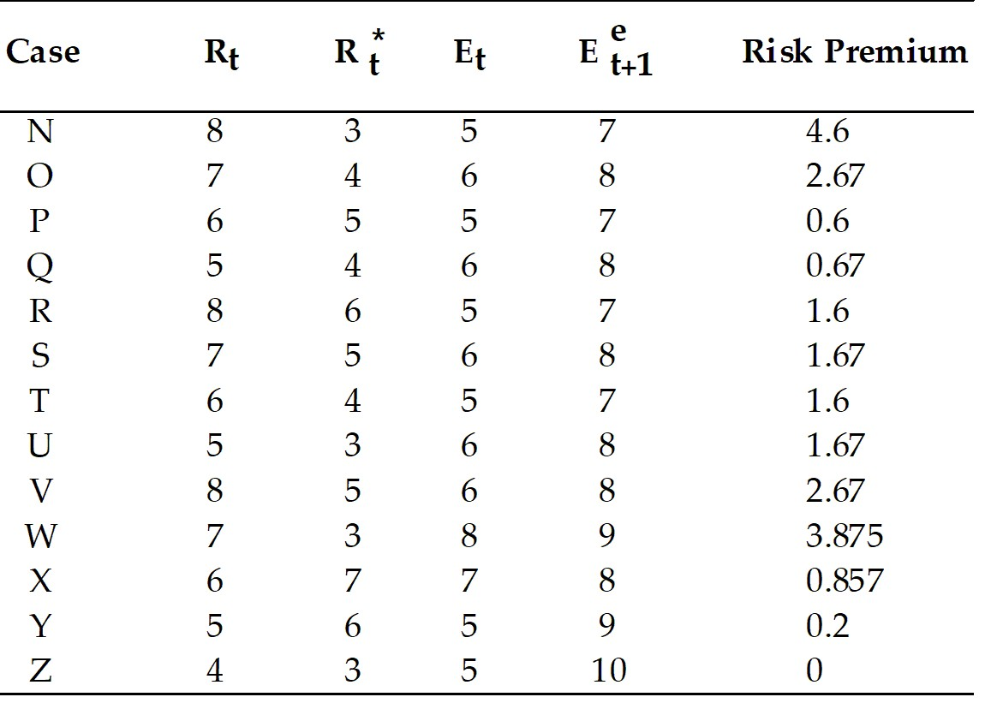

Difficulty: Difficult
AACSB: Application of knowledge

19) Assume interest parity holds. Calculate for each of the following cases.
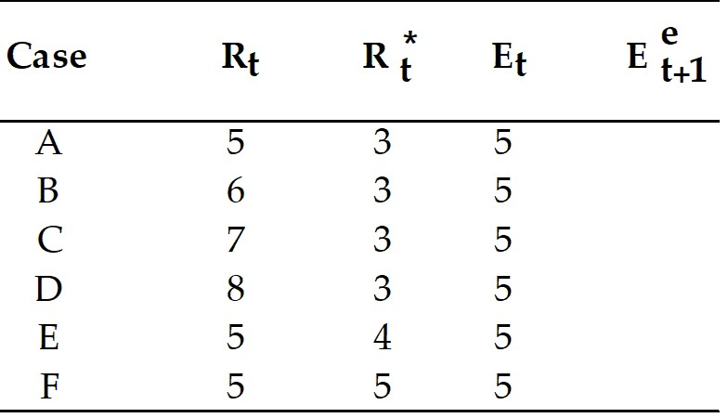

Answer:
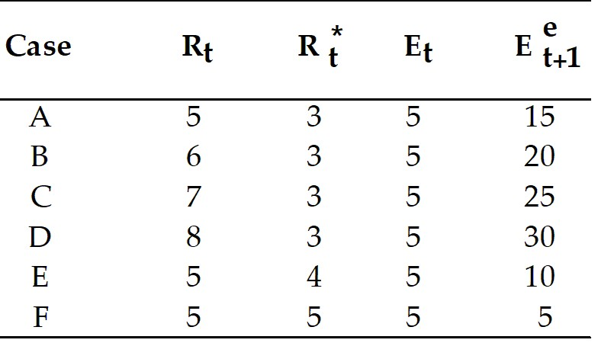

Difficulty: Moderate
AACSB: Application of knowledge

20) Assume interest parity holds. Calculate for each of the following cases.
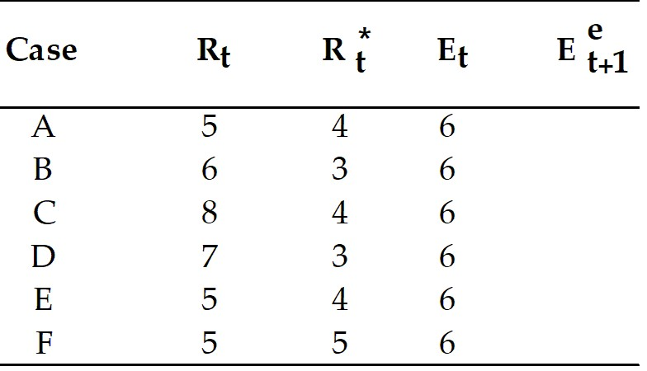

Answer:
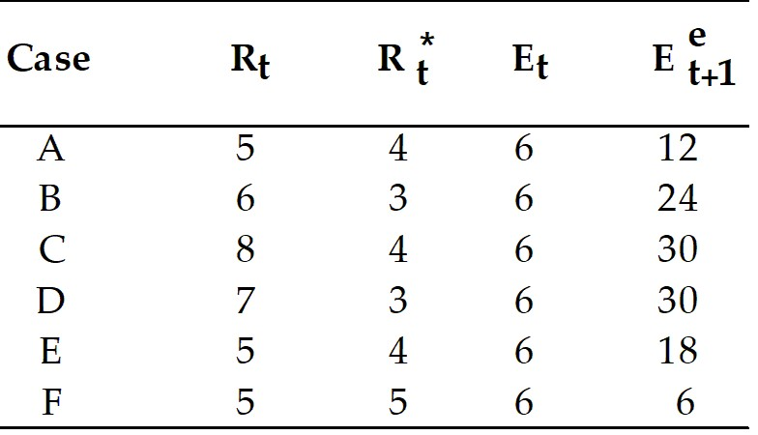

Difficulty: Moderate
AACSB: Application of knowledge

21) Does the interest rate parity hold in each of the following cases by using the formula
Rt - Rt = (Ee+1 - Et)/Et? In case it does not hold, calculate the risk premium.
1. Rt = 5,  = 3, Et = 5,  = 17
2. Rt = 6,  = 4, Et = 5,  = 5
3. Rt = 7,  = 5, Et = 5,  = 8
4. Rt = 8,  = 3, Et = 5,  = 15
5. Rt = 5,  = 4, Et = 6,  = 6
6. Rt = 5,  = 5, Et = 3,  = 10
7. Rt = 5,  = 6, Et = 2,  = 8
8. Rt = 5,  = 3, Et = 0,  = 20
9. Rt = 5,  = 9, Et = 7,  = 3
10. Rt = 5,  = 10, Et = 8,  = 7

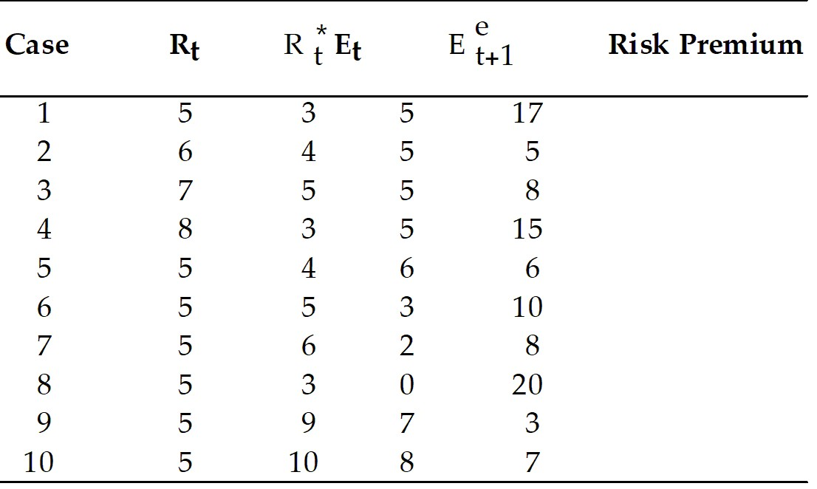

Answer:
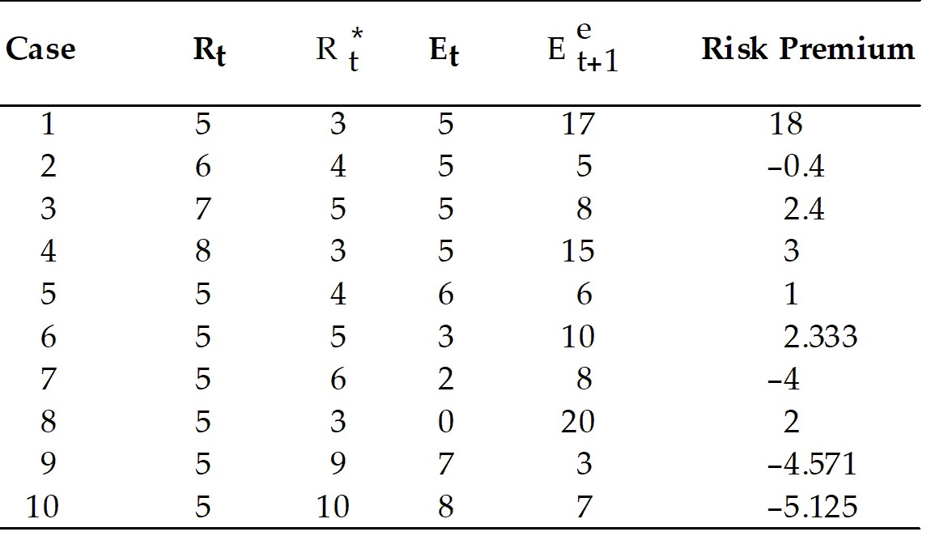

Difficulty: Difficult
AACSB: Application of knowledge

22) How well has the international capital market performed?
Answer: International portfolio diversification has increased.
Difficulty: Moderate
AACSB: Application of knowledge

23) What does the ambiguous evidence on the foreign exchange market's performance suggest?
Answer: The ambiguous evidence on the foreign exchange market's performance suggests an open-minded view. A judgment that the market is doing its job well would support a laissez-faire attitude by governments and a continuation of the present trend toward increased cross-border financial integration in the industrial world. A judgment of market failure, on the other hand, might imply a need for increased foreign exchange intervention by central banks and a reversal of the global trend toward external financial liberalization. The stakes are high, and we need more research and experience before reaching a firm conclusion.
Difficulty: Easy
AACSB: Application of knowledge

